**BUG FINDING FOR HOME TOWN AP**

**Bug Report-01**

1. **Title**: After opening home town home town home town app I search books but did not showing wrong message, showing different wooden product.
2. **Steps**:
3. Sign up the application with the mobile number and email.
4. Log in the application
5. Go to the home page
6. Click on the search bar and enter keyword to search
7. Verify your searching product

Bellow the attachment

3. **Expected result**: search bar should show the related search key .

4. **Actual result**: search bar showing the product which are not relevant.

5**. Attachment**: screenshot

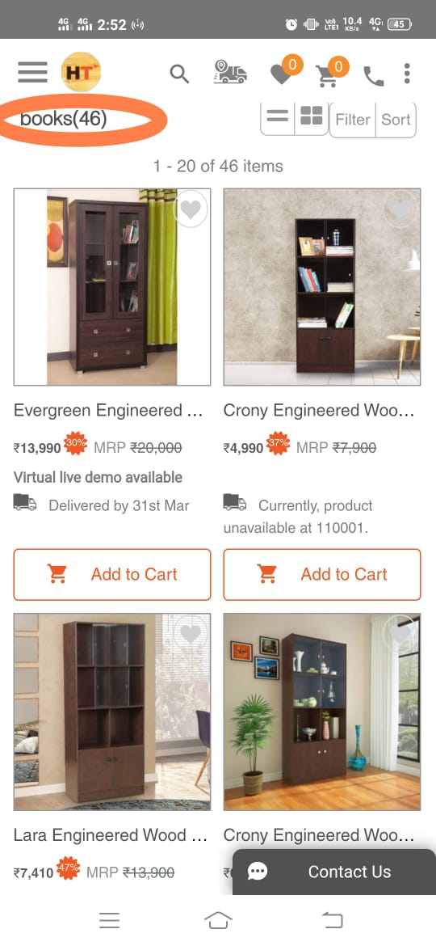

**Bug Report -02**

1. **Title**: I click on flat 10% offer and open the offer page then I click on the back symbol that time reopen the offer page after that when I click back symbol again that time it does not work .
2. **Steps:**
3. Sign up the application with the mobile number and email
4. Log in the application
5. Click on flat10%offer>click on back symbol>again click on back symbol.
6. Verify the result

Attachment bellow

1. **Expected result:** when I click back symbol again that time application should be work properly
2. **Actual result:** that time application does not workproperly.
3. **Attachment:** https://drive.google.com/file/d/1cAm7M0LtFEZ4q-P-6pGkaOkpJxSB7H1u/view?usp=drivesdk

**Bug Report-03**

1. Title: On the sign up page sign in and sign up writing is not proper align.
2. Steps :
3. Click on the app and open > click on three parallel line and go to the profile page
4. Click on sign up option
5. Verify the result

Bellow the attachment

1. Expected result: on the sign up page ,sign in and sign up writing should be proper align
2. Actual result: On the sign up page it is not write properly.
3. Attachment:

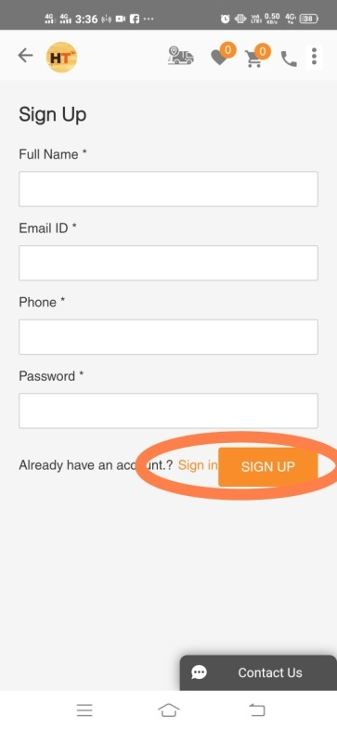

**Bug Report-04**

1. **Title**: click on the add address then open the address page there also have write add address.
2. **Steps**:
3. Click on the three dots
4. Then go to the my address
5. Verify the page

Bellow attachment

1. **Expected result**: on the address page should be shows address
2. **Actual result** :on the address page shows add address.
3. **Attachment:**

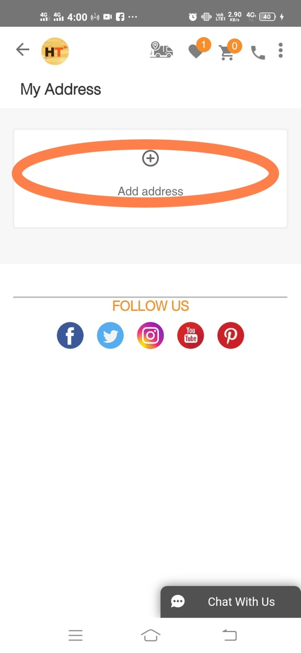 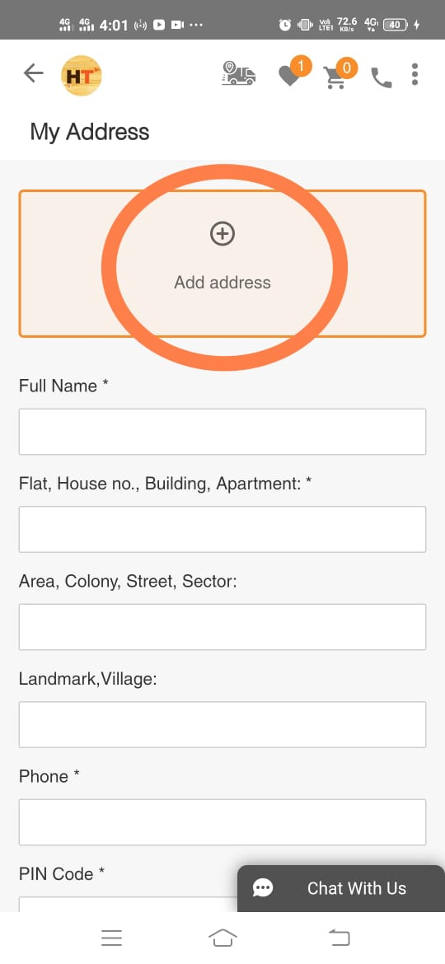

**Bug Report-05**

1. **Title** : click on the search bar and see the keyword opening then tap on blank page and see keyword is disappearing .
2. **Steps:**
3. Click on the app and open
4. Then click on search bar
5. Verify the result

Bellow the attachment

1. **Expected result**: click on the search bar and see the keyword opening then tap on blank page and see keyword should not disappearing .
2. **Actual result**: after taping blank page keyword disappearing.
3. **Attachment :**

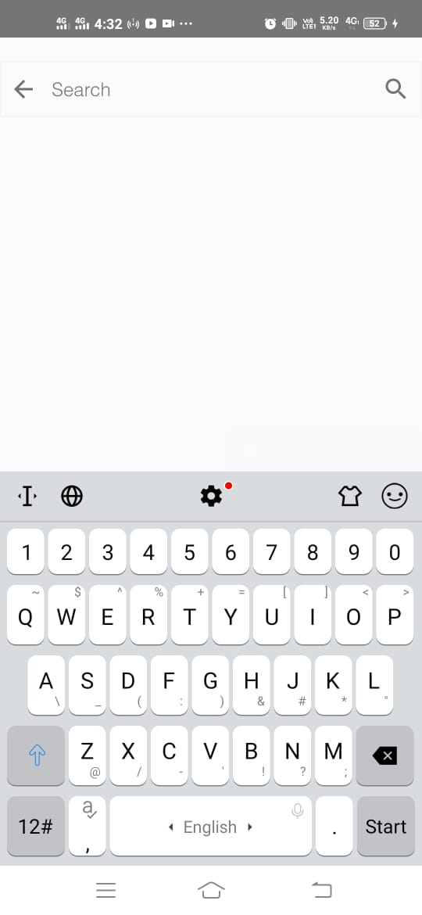 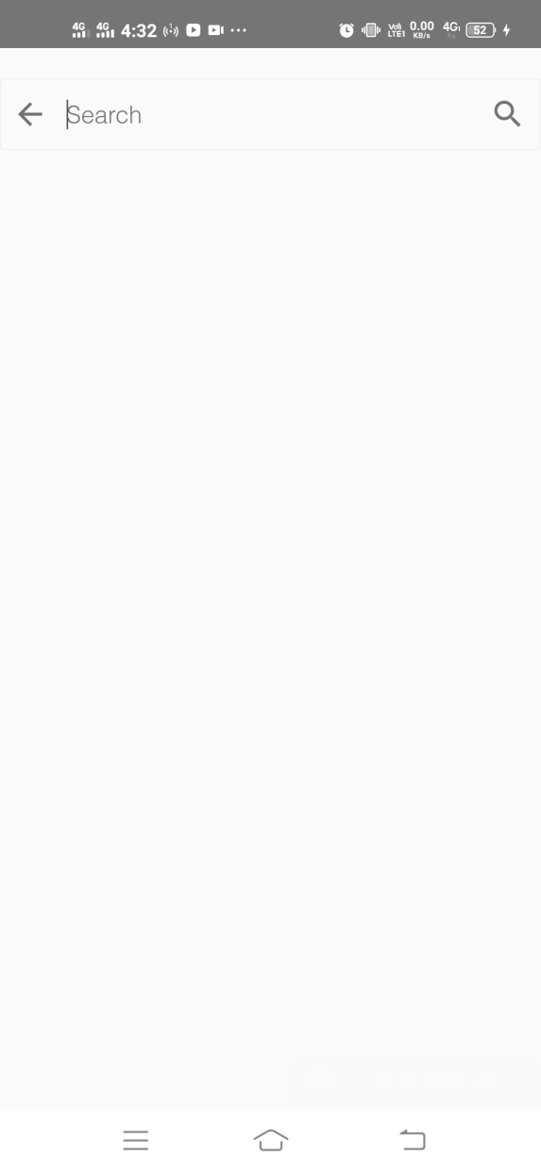

**Bug report-06**

1. **Title** : off internet then open the application in that time showing “the page is under maintenance will come back soon” does not show internet related any error massege.
2. **Steps**:
3. Off the internet
4. Then open the application
5. Verify the result
6. **Expected** **result** :it should show internet related message
7. **Actual** **result** : it does not show any internet related message .
8. **Attachment :**

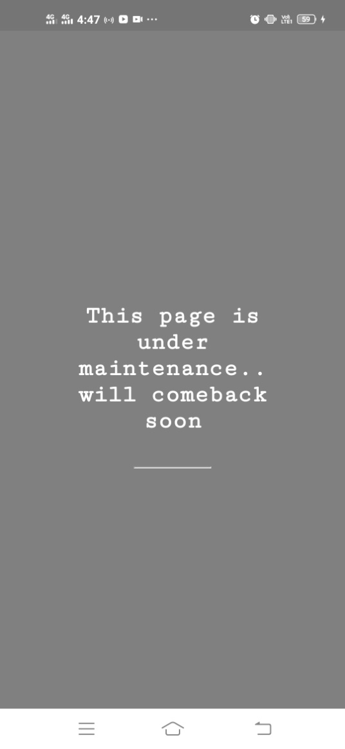

Written By Sulaiman.